海南大学信息科学技术学院
实 验 测 试 报 告
评定成绩 | 指导教师

实验课程： TCP/IP协议
实验测试名称：自制Sniffer ━ 抓取探测本机的ICMP报文
学号： 20151681310210 姓名： 崔晨凯 班级： 2
完成日期： 2017 年 12 月 1 日
- 实验测试内容
编程实现抓取ping命令探测本机的ICMP数据包和本机应答的ICMP数据包，显示时要求区分ICMP的类型、本类型的第几个数据包、源IP地址和目的IP地址。

- 实验环境
机型： hp 操作系统：win7 编程语言：C++ 开发软件：vs2010

- 实验过程及运行截图
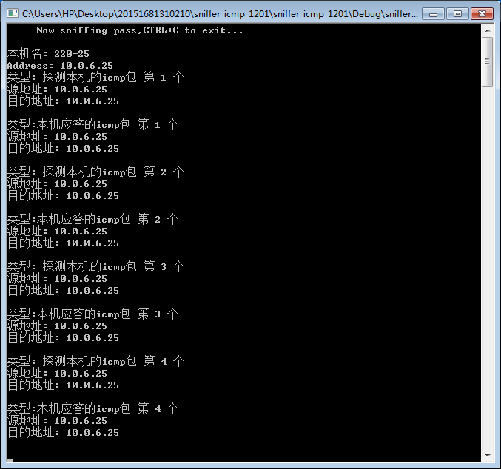
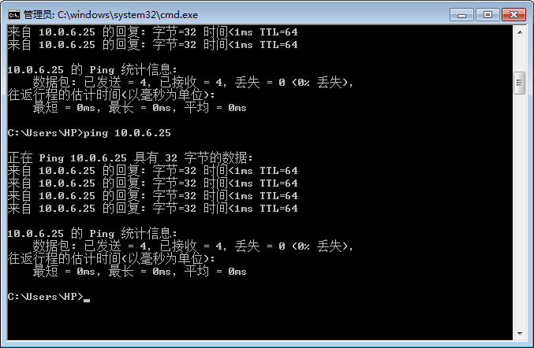
- 源代码
#include<Winsock2.h>
#include<stdio.h>
#include<stdlib.h>
#include<string.h>
#pragma comment(lib,"ws2_32.lib")//添加连接库

#define MAX_PACK_LEN 4096//接受的最大ip报文
#define MAX_ADDR_LEN 16//点分十进制地址的最大长度
#define MAX_HOSTNAME_LAN 255//最大主机名长度
#define SIO_RCVALL _WSAIOW(IOC_VENDOR,1)//i/o控制命令

typedef struct _iphdr //IP首部
{
unsigned char h_lenver; //4位IP版本号 + 4位首部长度
unsigned char tos; //8位服务类型TOS
unsigned short total_len; //16位总长度
unsigned short ident; //16位标识
unsigned short frag_and_flags; //3位标志位和13位片偏移
unsigned char ttl; //8位生存时间
unsigned char proto;//8位协议
unsigned short checksum; //16位IP首部校验和
unsigned int sourceIP; //32位源IP地址
unsigned int destIP; //32位目的IP地址
}IP_HEADER;

typedef struct _icmphdr //ICMP首部
{
unsigned char type; //8位类型
unsigned char code; //8位代码
unsigned short checksum; //16位校验和
}ICMP_HEADER;

//ip解包程序
int DecodeIPPack(char *buf,int iBufSize){

//显示IP头部

//创建包头指针
IP_HEADER *pIpheader=(IP_HEADER *)buf;
//显示ip包版本号
int iIphVer = ((pIpheader->h_lenver)>>4 &0xf);
//显示ip包头长度
int iIphLen = sizeof(unsigned long)*(pIpheader->h_lenver &0xf);
//显示服务类型
int iIphTos = pIpheader->tos;
//显示总长度
int iIphToatl_len = ntohs(pIpheader->total_len);
//显示标识
int iIphIdent = ntohs(pIpheader->ident);
//显示标志
int iIphFrag = ((pIpheader->frag_and_flags)>>13 &0x7);
//显示片偏移
int iIphFlags = ((pIpheader->frag_and_flags &0x1fff));
//显示生存时间
int iTTL = pIpheader->ttl;
//显示上层协议标识
int iIphProto = pIpheader->proto;
//显示头部检验和
int iIphChecksum = ntohs(pIpheader->checksum);
//显示源ip,目的ip
char szSourceIP[MAX_ADDR_LEN],szDestIP[MAX_ADDR_LEN];
SOCKADDR_IN saSource,saDest;
//获取源ip地址
saSource.sin_addr.s_addr=pIpheader->sourceIP;
//得到点分十进制字符串形式的ip地址
strncpy(szSourceIP,inet_ntoa(saSource.sin_addr),MAX_ADDR_LEN);
//获取目标IP地址
saDest.sin_addr.s_addr=pIpheader->destIP;
//得到点分十进制字符串形式的IP地址
strncpy(szDestIP,inet_ntoa(saDest.sin_addr),MAX_ADDR_LEN);

if(iIphProto==1){

static int count_check = 1;
static int count_reply = 1;
//显示ICMP头部

//创建包头指针
ICMP_HEADER *pIcmpheader=(ICMP_HEADER *)(buf+iIphLen);
//显示类型
int type = pIcmpheader->type;
//显示代码
int code = pIcmpheader->code;

//存放主机名称
char hostname[256];
gethostname(hostname,sizeof(hostname));
//主机信息指针
hostent *pHostent1;
struct sockaddr_in sa1;
int n;
pHostent1 = gethostbyname(hostname);
for(n=0; pHostent1->h_addr_list[n]; n++){
memcpy(&sa1.sin_addr.s_addr, pHostent1->h_addr_list[n], pHostent1->h_length);
//printf("Address: %s\n", inet_ntoa(sa1.sin_addr));
}
//
//
if(type==8&&code==0/*&&szDestIP==inet_ntoa(sa1.sin_addr)*/){
printf("类型: 探测本机的icmp包 第 %d 个\n",count_check);
printf("源地址: %s\n",szSourceIP);
printf("目的地址: %s\n\n",szDestIP);
++count_check;
}else if(type==0&&code==0/*&&szSourceIP==inet_ntoa(sa1.sin_addr)*/){
printf("类型:本机应答的icmp包 第 %d 个\n",count_reply);
printf("源地址: %s\n",szSourceIP);
printf("目的地址: %s\n\n",szDestIP);
++count_reply;

}

}

//------------------------
return 0;
}

SOCKET SockRaw;
//sock错误处理程序
void CheckSockError(int iErrorCode, char *pErrorMsg){
if(iErrorCode==SOCKET_ERROR){
printf("%s Error:%d\n", pErrorMsg, GetLastError());
closesocket(SockRaw);
exit(0);
}
}

void main(int argc,char ** argv){

int iErrorCode;
char RecvBuf[MAX_PACK_LEN]={0};
WSADATA wsaData;
char name[MAX_HOSTNAME_LAN];
struct hostent * pHostent;
SOCKADDR_IN sa;
DWORD dwBufferLen [10];
DWORD dwBufferInLen=1;
DWORD dwBytesReturned=0;

printf("---- Now sniffing pass,CTRL+C to exit...\n\n");
//
iErrorCode=WSAStartup(0x0202,&wsaData);
CheckSockError(iErrorCode,"WSAStartup");
SockRaw=socket(AF_INET,SOCK_RAW,IPPROTO_IP);
CheckSockError(SockRaw,"socket");

iErrorCode=gethostname(name,MAX_HOSTNAME_LAN);
CheckSockError(iErrorCode,"gethostname");
pHostent=(struct hostent *)malloc(sizeof(struct hostent));
pHostent=gethostbyname(name);
sa.sin_family=AF_INET;
sa.sin_port=htons(6000);
memcpy(&sa.sin_addr.S_un.S_addr,pHostent->h_addr_list[0],pHostent->h_length);
//绑定套接字
iErrorCode=bind(SockRaw,(PSOCKADDR)&sa,sizeof(sa));
CheckSockError(iErrorCode,"bind");
//将网卡的接受模式设置为混杂模式（设置SOCK_RAW为SIO_RCVALL）,以便接受所有的ip1包
iErrorCode=WSAIoctl(SockRaw,SIO_RCVALL,&dwBufferInLen,sizeof(dwBufferInLen),
&dwBufferLen,sizeof(dwBufferLen),&dwBytesReturned,NULL,NULL);
CheckSockError(iErrorCode,"Ioctl");

//存放主机名称
char hostname[256];
gethostname(hostname,sizeof(hostname));
printf("本机名: %s\n", hostname);

//主机信息指针
hostent *pHostent1;
struct sockaddr_in sa1;
int n;
pHostent1 = gethostbyname(hostname);
for(n=0; pHostent1->h_addr_list[n]; n++){
memcpy(&sa1.sin_addr.s_addr, pHostent1->h_addr_list[n], pHostent1->h_length);
printf("Address: %s\n", inet_ntoa(sa1.sin_addr));
}

while(1)
{
memset(RecvBuf,0,sizeof(RecvBuf));
iErrorCode=recv(SockRaw,RecvBuf,sizeof(RecvBuf),0);
CheckSockError(iErrorCode,"recv");
iErrorCode=DecodeIPPack(RecvBuf,iErrorCode);//对收到的ip包进行解包
CheckSockError(iErrorCode,"Decode");
}
}

- 总结

